ELECTRONICS AND SENSORS

PROPOSAL

# Sensors

The sensors we have chosen to install in our bot and their selection process are explained below.

## IMU

An Inertial measurement unit is fixed to the bot, so that we get the accurate position as well orientation of the bot at all times. This will be used in the navigation algorithm to provide commands to the bot. IMU consists of an acceleration sensor coupled with a gyroscope which gives us the angular velocity and external specific force acting on the body. This data is further processed to obtain the position and orientation.

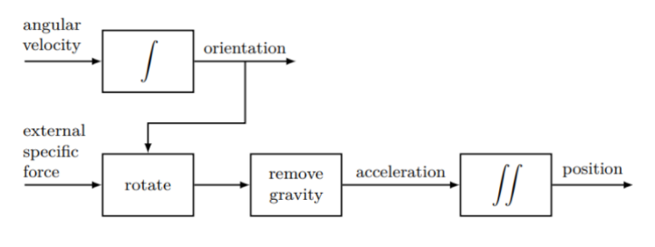After considering about 4-5 products, we chose the **MPU-6050** by **InvenSense** which has a triple-axis MEMS gyroscope and accelerometer, supporting both I2C and SPI protocols.

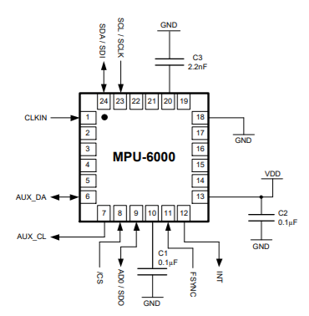

## LIDAR

We utilize the Light Detection and Ranging (LIDAR) mechanism to map and understand the environment around the bot and thus proceed to navigate through it. The LIDAR module fit on top of the bot serves dual purposes of both understanding the environment and detecting obstacles if any. We also implement a sensor fusion algorithm to get a better accurate position of the bot with respect to the environment.

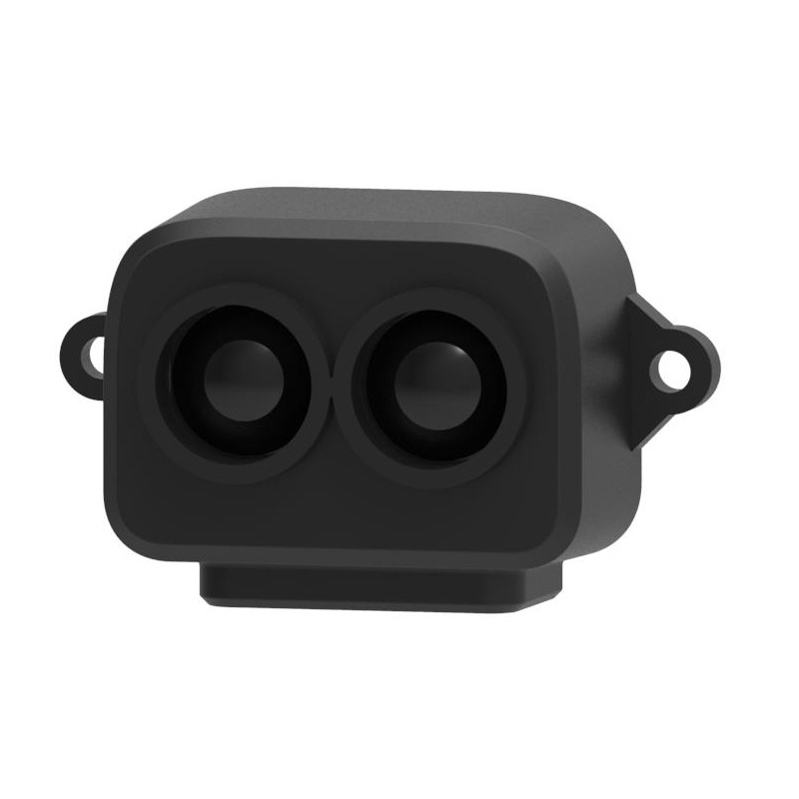

We chose the TF-LUNA Micro LiDAR for our purposes as it has a very good accuracy of about +/- 2% and works very well upto a range of 8m. Also it supports the I2C interface and hence can be easily integrated into the ESP32 system. It is built with algorithms adapted to various application environments and adopts multiple adjustable configurations and parameters so as to offer excellent distance measurement performances in complex application fields and scenarios.

# Controller

Our Main controller, ESP32 WROOM board with a dual core processor, is a powerful, generic Wi-Fi+BT+BLE MCU module best suited for low-power sensor networks. It gives the best performance for electronic integration, range, power consumption, and connectivity. These are the hardware specifications :

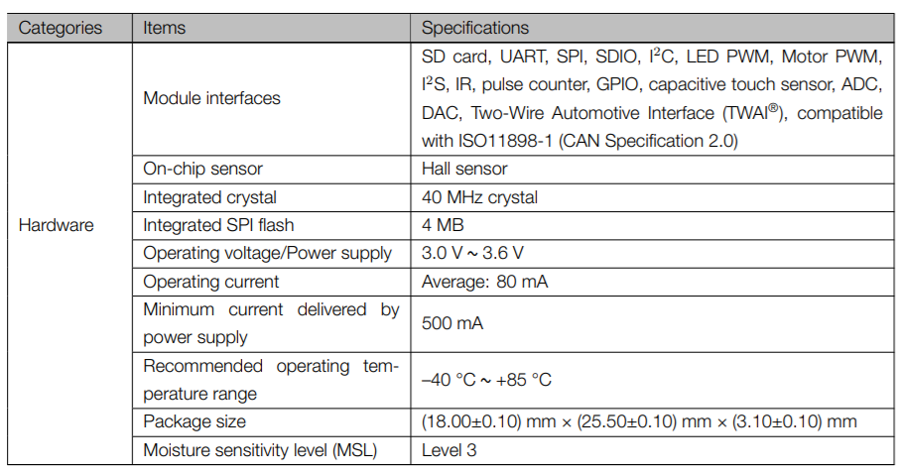

**ESP32 Wroom Module**

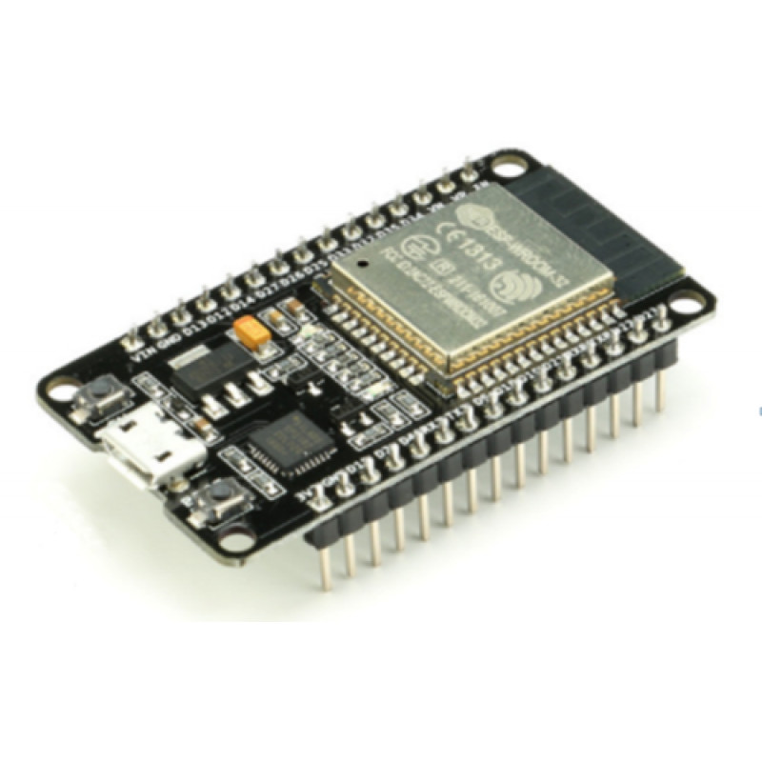

# Battery Pack

Crucial aspects we considered while choosing the power solution for the bot were :

1. Provide enough power to all components
2. Should last long enough for one clean without having to recharge in middle
3. Minimum calendar ageing

Based on our calculations, we decided that the battery pack must be of 14-18 V with a minimum capacity of 3000 mAh. It must last at least for an hour without having to recharge in the middle. We chose to go with a battery pack consisting of **LG HG-2 18650 3000 mAh Li-ion batteries**, as they had superior energy density and longer calendar life.

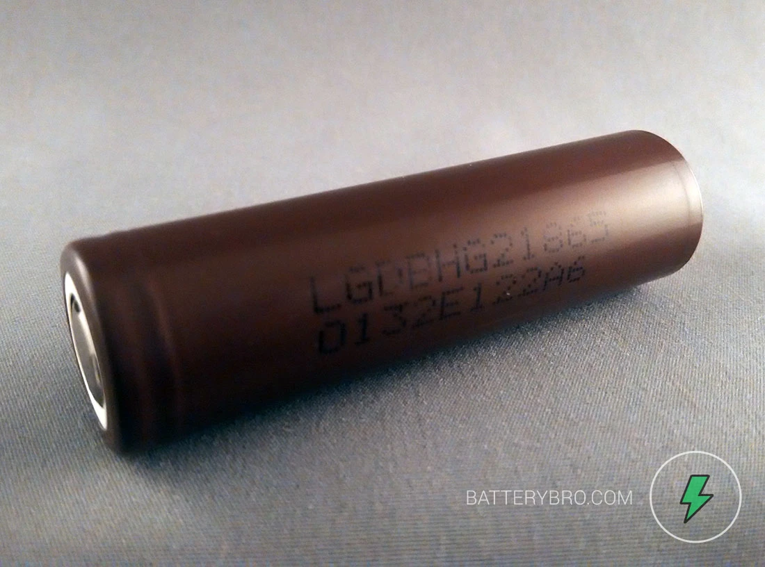

# Motors

We need two kinds of motors in total for our bot, One to drive the wheels and the other to drive the vacuum fan. We explain our selection for the same in this section.

## DC Gear Motor

To drive the wheels, We have the RS-540SH-5045 with a 50 W power delivered to wheels. This is a 12V DC motor which can run till 18000 RPM.

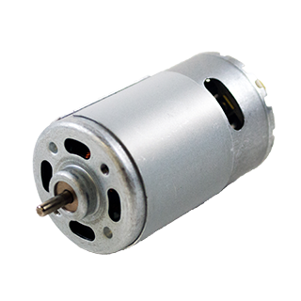

## DC Motor - Fan

We would need a DC motor to run the vacuum fan which should provide a reasonable RPM powerful enough to collect dust. We have chosen the 12V - 3000 RPM DC Motor for this purpose.

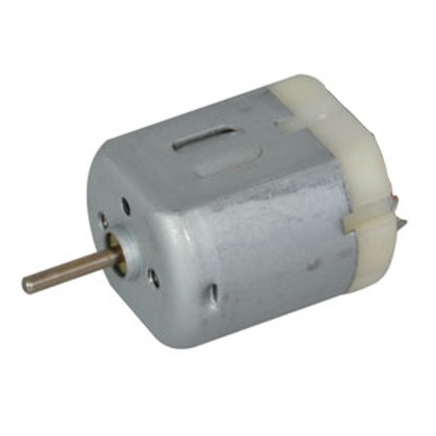

# Electronics Cost

| Component | Qty | Cost |
| --- | --- | --- |
| IMU | 1 | Rs. 250 |
| LIDAR | 1 | Rs. 2000 |
| Controller | 1 | Rs. 500 |
| LG HG2 18650 | 4 | Rs. 2000 |
| DC Gear Motor | 2 | Rs. 1500 |
| DC Motor | 1 | Rs. 90 |

**Total Cost : Rs. 6340**